**To check server link:** <http://localhost:8080/RobobankCSP/>

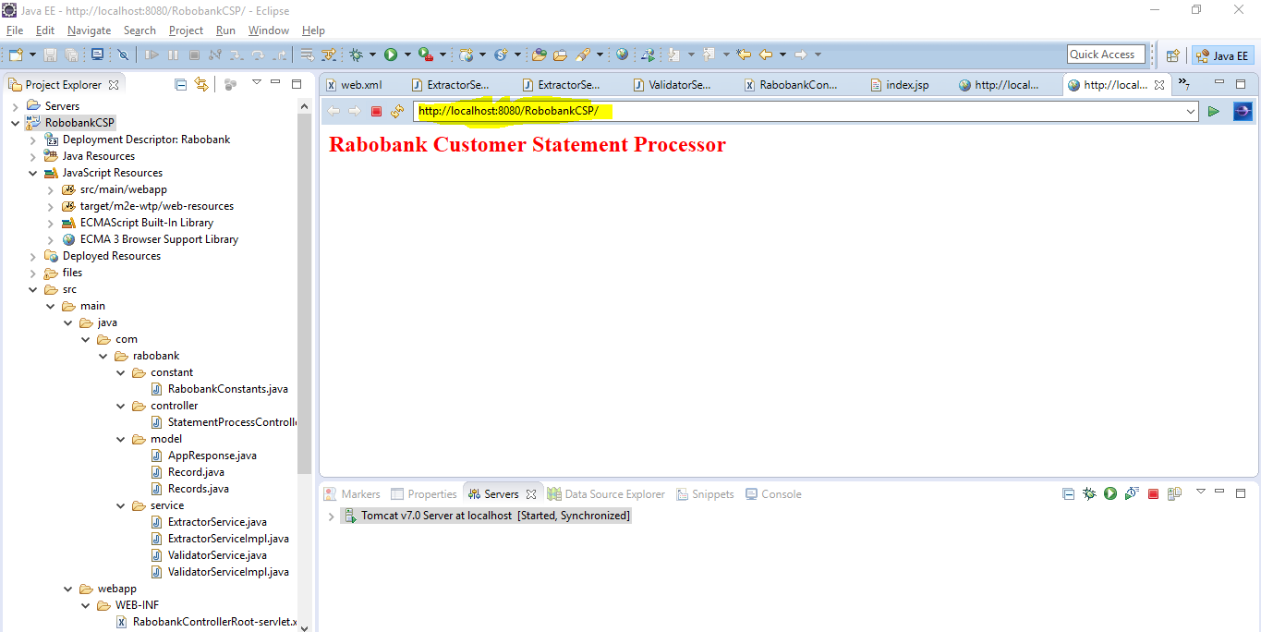

Run in postman to check the test result: <http://localhost:8080/RobobankCSP/rabobank/processStatment>

**File type CSV/XML allow to retrieve data:**

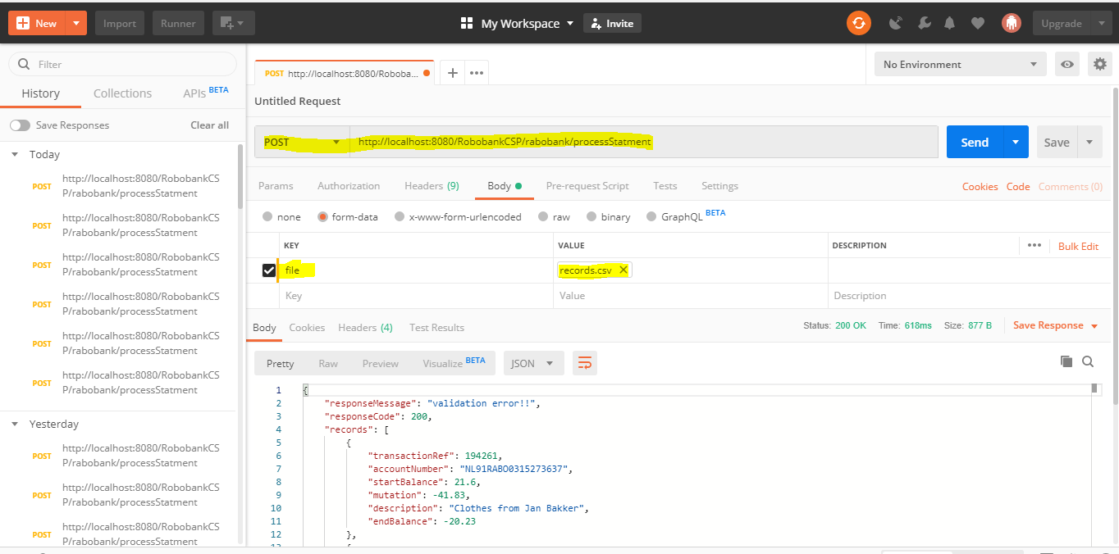

**File type is not XML/CSV throws error:**

